**Student ID:** 18101003

**Student Name:** Rakin Mohammad Sifullah

**Project Name:** Voice to Binary Conversion using C/Python/Java

**Programming Language:** Python

**Libraries used:** join, playsound(), Recognizer()

**System Requirements:** Python, PyCharm

**Algorithm (Python):**

Step 1: Start PyCharm

install pip3 install SpeechRecognition pydub,

pip3 install playsound

Step 2:

import speech_recognition as sr  
import binascii  
from playsound import playsound

Step 3: Declare audio file

Step 4: Print audio in text

Step 4: Print text in binary

Step 5: Convert string to binary using “Join” function

Step 6: Print the Binary Representation

**Flowchart:**

Part 1

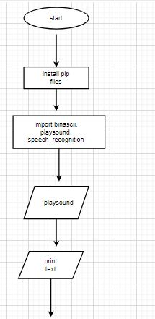

Part-2

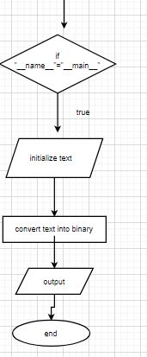

**Source Code / Screenshot of code**:

import speech_recognition as sr  
import binascii  
from playsound import playsound  
  
filename = "here-i-come.wav"  
playsound(filename)  
  
r = sr.Recognizer()  
  
with sr.AudioFile(filename) as source:  
 audio_data = r.record(source)  
 text = r.recognize_google(audio_data)  
 print(text)  
  
 if __name__ == "__main__":  
 text_to_convert = text  
 print(str(text_to_convert))  
 text_in_bin = ''.join(format(ord(i), 'b') for i in text)  
 print(str(text_in_bin))

**Output (Screenshot):**

